Darts With Friends

Team Member : Josh Erkman

### Table of Contents

Table of Contents

Mission Statement

Database

Features

Trello Link

Wireframe

Schedule

Final Notes

### 

### 

### Mission Statement

Darts With Friends is committed to bringing friends together in a positive environment to play darts utilizing our scoring system for quick and easy score keeping.

### 

### Database

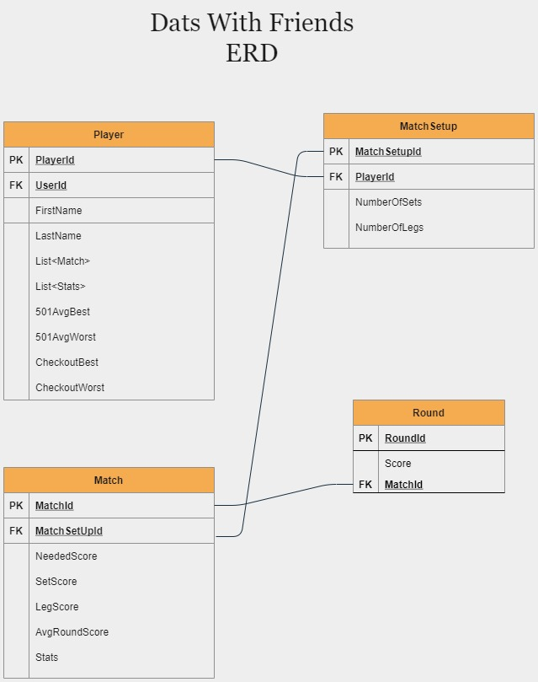

Table 1

Player: PlayerId int, UserId Guid, First Name string, Last Name string, MatchList List<Match>, StatsList List<Stats>, 501AvgBest int, 501AvgWorst int, CheckoutBest (stretch goal) int, CheckoutWorst (stretch goal) int

Table 2

MatchSetup: MatchSetupId int, PlayerId int, NumberOfSets int, NumberOfLegs int

Table 3

Match: MatchId int, MatchSetupId int, NeededScore int, SetScore int, LegScore int, AvgRoundScore int, stats int

Table 4

Round: RoundId int, MatchId int, Score int

Optional: table 4 add on of checkoutBest and checkoutWorst

Endpoints

Localhost/api/player

Localhost/api/MatchSetup

Localhost/api/Match

Localhost/api/Round

### Features

|  |  |
| --- | --- |
| Version 1.0 / MVP | Version 2.0 / Stretch Goals |
| * UserIdentity creates player * Add 2 players to a match * Set up match * Enter 3 dart score * Automatic needed score update * Visible fluid average in match * View Stats for searched playerId * Checkout guide * Visible leg and set score | * Checkout Best * Checkout Worst |

### 

### Trello Link

### https://trello.com/b/dxJol8at/darts-with-friends

### Schedule

|  |  |  |  |  |  |  |
| --- | --- | --- | --- | --- | --- | --- |
| **Day 1** | **Day 2** | **Day 3** | **Day 4** | **Day 5** | **Day 6** | **Day 7** |
| Scaffold Out Project |  | Create POCOS |  | Create Data Models |  | Service Controller View for Player |
| **Day 8** | **Day 9** | **Day 10** | **Day 11** | **Day 12** | **Day 13** | **Day 14** |
|  | Service Controller View For MatchSetup |  | Service Controller View for Match |  | Service Controller View For Round |  |
| **Day 15** | **Day 16** | **Day 17** | **Day 18** |  |  |  |
| Add styling |  | Add Styling  Stretch Goals |  |  |  |  |

### Final Notes

Great job with planning! You are now set to start coding. Planning a project is incredibly beneficial to the success of your team and your project. Here are some resources to help you with your planning.

* [How to plan a web application](https://selftaughtcoders.com/plan-web-application/)
* [Step By Step: Planning a web application](https://medium.com/@ericwindmill/step-by-step-planning-a-web-application-ddaa010a8353)